Problem-Solving Studio 3B – Blood Flow through the heart, Cardiac Cell Excitability Mechanisms, EKG Data Analysis
BMED 3100
Oct 20, 2025
Group Number: _____
Names: _______________________________________________________________________

Purpose & Structure of PSS
Problem-Solving Sessions help you actively connect foundational physiology to applied reasoning in clinical cases.
Section 1 – Getting Foundational Knowledge Down
Reinforces essential cardiac foundations—including blood flow, valve function, electrical conduction, and normal EKG patterns—to ensure everyone begins with a shared conceptual baseline before tackling more complex disease mechanisms.
Section 2 – Establish Foundational Knowledge to Clarify Misconceptions:
Applies those foundations to interpret how mitral valve disease, atrial fibrillation, and pacemaker function alter normal physiology. Learners use these links to predict pressure changes, electrical abnormalities, and EKG findings in the patient's case.
Case 15-2018: An 83-Year-Old Woman with Nausea, Vomiting, and Confusion Melissa L.P. Mattison, M.D., Victorine V. Muse, M.D., Leigh H. Simmons, M.D., Christopher Newton‑Cheh, M.D., M.P.H., and Rory K. Crotty, M.B., B.Ch., B.A.O.
An 83-year-old woman was admitted to the hospital during the winter with symptoms of nausea, vomiting, confusion, and weakness. One week before admission, she had developed a runny nose, sore throat, and a nonproductive cough but did not report any fever. Two days before admission, she began experiencing nausea, vomiting, and diarrhea. By the following day, her daughter noticed that she was asking repetitive questions and failing to recognize family members. On the day of admission, she reported feeling globally weak, prompting her daughter to bring her to the emergency department for evaluation.
The patient had a history of rheumatic heart disease, a chronic heart condition that develops as a complication of rheumatic fever and had undergone mitral valve replacement and tricuspid valve repair. She also had a permanent ventricular single chamber pacemaker, an electronic device that controls the heartbeat pacing by connecting the lead to the right ventricle, due to persistent bradycardia. Her cardiovascular conditions included a narrowing (stenosis of the mitral valve, which makes it harder for blood to flow forward, and a leaking (regurgitation mitral valve, which allows some blood to flow backward instead of moving in the right direction. In addition to atrial fibrillation, which resulted in an irregular and uncoordinated atrial contraction. On examination, her blood pressure was 153/60 mmHg, her pulse was 64 beats per minute, and her respiratory rate was 18 breaths per minute. She looked extremely thin and weak, seemed very tired, and gave confused or nonsensical answers to questions. An electrocardiogram (EKG) revealed an absence of distinct P waves, confirming the presence of atrial fibrillation. Despite having a pacemaker, her atria continued to fibrillate.
Her medical regimen included furosemide, a diuretic used to manage fluid retention; metoprolol, a beta-blocker to control heart rate; digoxin, a drug that enhances acetylcholine release from the vagal nerve that is part of the parasympathetic system that innervates the heart; and warfarin, an anticoagulant to reduce the risk of clot formation. Given her history of mitral valve disease and atrial fibrillation, her symptoms of weakness and confusion raised concerns about possible complications related to her cardiac condition.
______________________________________________________________________
Section 1 – Getting Foundational Knowledge Down
(Topical scaffolds to support later reasoning in Section 2)
Learning Objectives
By the end of this section, you should be able to:
- Understand how clinicians perform disease diagnosis via ECG.
- Evaluate accuracy of Machine learning models to diagnosis cardiac events via ECG
- Understand pros and cons of large data and visual approaches to cardiac disease diagnosis
- Trace normal blood flow through the heart and describe how each valve ensures one-way movement of blood.
- Differentiate AV and semilunar valve functions and relate them to pressure changes during the cardiac cycle.
- Describe the sequence of electrical conduction in the heart and the timing of atrial and ventricular contraction.
- Distinguish conducting (autorhythmic) from contractile cardiac cells, identifying their respective physiological roles.
- Label major EKG waves and explain how they correspond to electrical events in the cardiac cycle.

Data Skills Problems:
Zip file of Matlab materials: BMED3100_PSS
Spreadsheet to share class results: ECG Classification PSS Fall 2025.xlsx
1. One of the first tests administered to the patient was an electrocardiogram (ECG). Pretend you are an ER resident. An ER attending physician (your boss) reports that the patient is NOT in atrial fibrillation (A-Fib), but you disagree.
- Only one person from your group needs to run the provided Matlab code, but each group member is welcome to run the code on their personal laptop. Ensure you have Matlab 2023, 2024, or 2025 with the Statistics and Machine Learning AND the Signal Processing Toolboxes installed.

- Download the Matlab files from the link files above. Find it on your computer, unzip the folder, and then from within that folder open the file: BMED3100_ECG_PSS_compressed.mlx

- Examine the following ECG and annotate it, i.e. mark the features that you think could indicate the patient is in A-Fib.
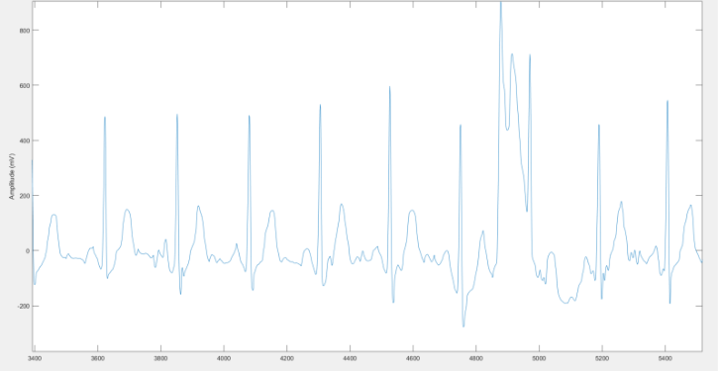

- Run SECTION 1 of the Matlab code (read the instructions in Matlab carefully). When it is done running you will see displayed at the bottom of SECTION 1 (not in the command window) two ECGs that are the same for everyone in the class (#4 and #1) and one random ECG that is different for each team. Look at the signals and decide whether you think each is an A-Fib signal and why. Enter those decisions in the spreadsheet you were sent the link to. [Completion grade only]
When you are done, as a team discuss the questions below. As everyone finishes, you will discuss them as a class:
- Were your diagnoses correct? (The correct classification for ECGs 4 and 1 will be discussed as a class.) [Completion grade only]
#4 is A-fib and #1 is not
These ECGs are part of the KEY ONLY
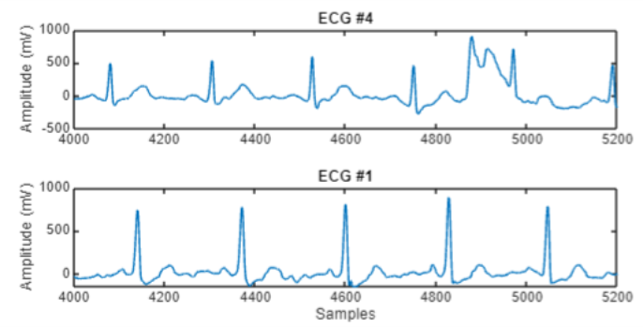

- What did you see in the plots that led you to make the choice you did? [Completion grade only]
In class, students can discuss things like the T-P segment being non-flat indicating abnormal electrical signaling before the P wave (atrial depolarization). This can also lead to a review of the parts of an ECG if they don’t really know what to look for.
Students could consider the P-R interval, the time it takes for SA node signal to get to AV node. This isn’t directly relevant to A-fib.

- Why does A-Fib result in the changes you indicated in part 1A to the ECG signals? [graded]
Since atrial fibrillation results in disorganized atrial contractions, there would be a reduced or absent P wave that corresponds to the atrial cells not depolarizing all at the same time. In general, abnormalities prior to the QRS complex would be visible.
iii. If your patient has a single-chamber ventricular pacemaker because of a slow heart rate (bradycardia) associated with atrial fibrillation.
Explain why a pacemaker device may be needed in this condition and why it does not restore normal atrial contractions.
Template Answer:
In atrial fibrillation, the atria generate rapid, uncoordinated electrical impulses. These signals reach the AV node irregularly, so the ventricles contract inconsistently and sometimes too slowly.
A ventricular pacemaker delivers regular electrical impulses directly to the right ventricle, ensuring it contracts at a steady, safe rate.
However, because the pacing lead is only in the ventricle, it does not control or coordinate atrial activity—the atria continue to fibrillate, so no normal P waves appear on the EKG.
TAs – Common Misconceptions:
“Pacemaker cells contract the heart.” → They only generate rhythm.
“A pacemaker cures atrial fibrillation.” → It only regulates ventricular rate, not atrial rhythm.
“All pacemakers stimulate both chambers.” → This case involves a ventricular single-chamber pacemaker.

- What was challenging about making the diagnoses? [Completion grade only]
Run section 2 of the Matlab code. There are two options. If you have Matlab 2024 – run section 2A. If you have Matlab 2023, run Section 2B. Your version of Matlab can be found in the the very top left of your Matlab window, by the Matlab icon. Once your code is running, continue reading.
Interestingly, ECGs are not something that even cardiologists are 100% accurate at analyzing. With the increasing prevalence of AI prediction tools, hospitals would be interested in a tool that can accurately, with low false positives and low false negatives, predict A-Fib. We trained a deep learning model on about 8000 ECG signals¹. Training means the model learned what to look for in ECGs to best predict A-Fib/not A-Fib. When it was done training, we calculated the accuracy of the classification – meaning for the data it used to learn to classify A-Fib/not how accurate is the model.
Overall, the model had 87% accuracy at correctly classifying the data it was trained on. A confusion chart (see below) showed that model correctly classified A-Fib 3738 times, misdiagnosed A-Fib as NOT A-Fib 280 times, and misclassified NOT A-Fib as A-Fib 734 times.
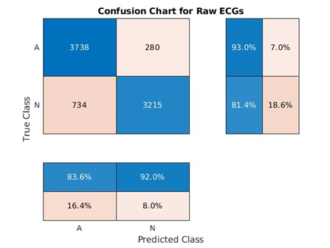
Your job is to test the model that we trained on ECG data the model has never seen before. That is, you get to use it for inference – meaning to look at a new signal and classify it as A-Fib/not A-Fib. The code in Section 2 does the inference step on 998 new ECG signals that the model has never seen before. That allows us to test the accuracy of our model.
While the code is running, (between 2 and 5 minutes), start working on the problems below (f - i).
- Why might a raw ECG signal be challenging to fit to a mathematical model? [Completion grade only]

Students may be confused by the non-specificity of this question. There are some things about ECGs that are “easy” to quantify (peak-to-peak interval for example = HR). Raw ECG signals (in the time domain) may be harder to fit compared to changing them to the frequency domain instead. Other examples...
A raw ECG signal has many potential issues – noisy signal (bad electrode placement?), etc. Students should identify one or more relevant issues.

- Enter the data from Section 2 of the code into the spreadsheet. You should enter the time it took to run (inference_time), the overall accuracy (Test_Accuracy) and the true positives, false positives, true negatives, and false negatives from the “confusion chart” that prints below Section 2. What do you think about the accuracy of this model for diagnosing AFib in clinical settings? [Completion grade only]
- What do you notice about the test accuracy you just calculated when you compare it to the training accuracy we presented above? [completion grade only]
Now run section 3 of the code
The first model we trained to classify ECGs as having A-Fib or not did so by looking at raw ECGs, i.e., the electrical signal data itself. As you just found, the model worked alright (~87% accurate) on the training data, but from when tested against a new set of data, the accuracy was much lower. We trained a second model using a technique called feature extraction to try and improve the accuracy of our classification tool.
Feature extraction takes raw data and processes it to make it easier for the neural network to understand. In this case, we used things that you know about the heart, heart rhythms, and ECG signals to do that. Specifically, we converted the ECGs from the time domain to the frequency domain. We did that using three signals analysis tools: a power spectrum, instantaneous frequency, and spectral entropy. Instantaneous frequency is the frequency of a given signal at any point in time. While some signals have a constant frequency (e.g., a sine wave), sometimes the way in which a signal changes frequency can provide useful information about what is happening in it. Spectral entropy quantifies the disorder or complexity of a signal. Signals with more spectral entropy have more randomness than those with less (i.e., their energy is spread more evenly across the frequency domain). As with instantaneous frequency, differences in spectral entropy can provide insights that looking at the raw signal cannot. We extracted instantaneous frequency and spectral entropy from each ECG in our dataset and used those features to train the second model.
- Section 3 of the code will produce three pairs of charts, one for power spectrum, one for instantaneous frequency, and one for spectral entropy. For each pair, an ECG without A-Fib is plotted first and an ECG with A-Fib is plotted second. Looking at each pair of graphs, please try and describe the differences between A-Fib and not A-Fib that you see. [completion grade only]
Now run section 4 (either 4a or 4b depending on your Matlab version)
- Enter the same results (time, accuracy, True positive, etc.) as you did for the first model into the spreadsheet starting in column R. [completion grade only]
The accuracy of the feature extracted model during training was 95%. Compare your test data accuracy to the training data accuracy and provide your thoughts on this model. Is it better for clinicians to use this model even if the signals it is trained on are harder to interpret by human eye? [completion grade only]

- As an ER resident, you make the decision to treat the patient in the case study as if she is in A-Fib by administering metropol, a beta-1-blocker. Beta-1 blockers work by reducing the heart rate and decreasing the force of contraction. Would metoprolol affect A-Fib? Explain why.
Template Answers
Beta 1 blockers work by reducing the heart rate and decreasing the force of contraction, which helps control the ventricular rate in A-Fib. By blocking beta-1 adrenergic receptors in the heart, metoprolol slows down the transmission of electrical impulses through the AV node, which is crucial for rate control in patients with A-Fib. However, metoprolol does not directly convert A-Fib into normal sinus rhythm; it primarily helps to manage symptoms by preventing rapid heart rates.
- If you had decided that the patient was not in A-Fib but she actually was (a false negative), what would be the consequences of untreated A-Fib in terms of blood pressure?
Template ans: Failing to diagnose A-Fib leads to unmanaged irregular heart rhythms, putting the patient at risk for both short-term blood pressure variability and long-term chronic hypertension. These complications can further progress to heart failure and increase the risk of systemic events such as stroke.
_________________________________________________________________________________
Section 1 Continued:
1. Direction of Blood Flow Through the Heart
On the whiteboard diagram a heart and use a different colored marker to show the correct sequence of blood flow through the major chambers and valves, starting from the systemic veins and ending with the systemic arteries. Make sure to label all the relevant parts like the chambers, the cardiac valves, the major blood vessels
Template Ans: TAs it’s okay if students draw 4 boxes to represent the heart chambers- that's what I’ll be doing! But watch for: skipping the lungs or confusing tricuspid/mitral positions.
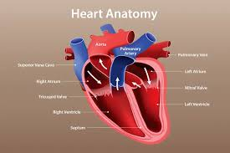
2. What Causes Heart Valves to Open and Close, and What Are Their Main Functions?
Explain what drives the opening and closing of the atrioventricular (AV) and semilunar valves (SL) and describe their key roles in maintaining effective blood flow.
Template Answer:
TAs – Watch for: Students saying valves “create pressure” → clarify they respond to pressure, enabling efficient pressure buildup.
Confusing AV vs. semilunar timing (AV open during diastole; semilunar open during systole).
Heart valves open and close in response to pressure differences between chambers:
- AV valves (mitral and tricuspid): open when atrial pressure > ventricular pressure during filling, and close when ventricles contract and pressure rises above atrial pressure to prevent backflow.
- Semilunar valves (aortic and pulmonary): open when ventricular pressure > arterial pressure during ejection, and close when arterial pressure exceeds ventricular pressure as the heart relaxes.
These pressure-driven movements ensure one-way blood flow and help build the pressure gradients needed to push blood forward through the heart and circulation.
3. Electrical Conduction Pathway
On the whiteboard diagram the normal intrinsic conduction pathway of the heart.
Template Answer: TAs – note: emphasize that atria contract first, then ventricles.
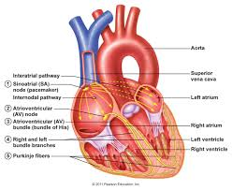
SA node → atrial muscle → AV node → bundle of His → right and left bundle branches → Purkinje fibers → ventricular muscle.
4. Cardiac Action Potentials — Conducting vs. Contractile Cells
Draw and label the action potential for both pacemaker (nodal) and contractile (myocardial) cells.
Identify key ion channels and phases for each.
Template Answer:
Nodal Cells Contractile Cells
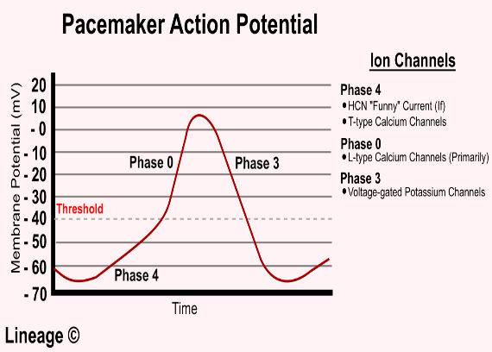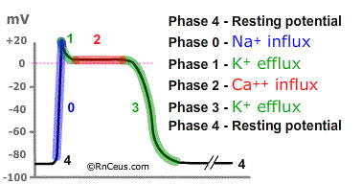

5. Interpreting the EKG
Using the EKG diagram provided below label the EKG waves and match each labeled EKG wave or interval to the corresponding electrical event: Keep this diagram handy you will use in Q 8 coming up!
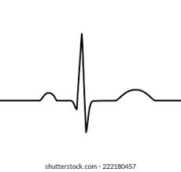
TA: Leave in ALL TEXT IN BLACK FONT AND LEAVE OUT RED FONT in the table below
EKG Component | Electrical Event | Physiological Meaning
P wave | Atrial depolarization | Initiation of atrial contraction
PR segment | Impulse delay at the AV node | Allows ventricles time to fill before contraction
PR interval (beginning of P to beginning of QRS) | Atrial depolarization + AV node conduction | Total time for impulse to travel from atria to ventricles
QRS complex | Ventricular depolarization (atrial repolarization hidden) | Triggers ventricular contraction
ST segment | Ventricles fully depolarized; plateau phase | Represents the time between depolarization and repolarization; normally isoelectric or flat line
T wave | Ventricular repolarization | Ventricles return to resting state
QT interval (beginning of QRS to end of T) | Entire period of ventricular depolarization and repolarization | Duration of ventricular electrical activity
_________________________________________________________________________________
Section 2: Using Foundational Knowledge
Now that you’ve reviewed how blood flows through the heart, how electrical signals coordinate contraction, and what a normal EKG looks like, you’re ready to examine how valvular defects, atrial fibrillation, and pacemaker therapy disrupt these processes in Section 2.
Learning Outcomes: By the end of this section, you should be able to-
- Explain how valvular stenosis and regurgitation alter cardiac pressures, blood flow, and pulmonary symptoms.
- Predict which cardiac chambers experience pressure overload in mitral valve disease and explain why.
- Compare pacemaker and contractile cell action potentials and describe how pacemaker activity is regulated.
- Explain why a pacemaker may be required in atrial fibrillation and what it can—and cannot—correct.
- Connect structural and electrical changes in mitral valve disease and atrial fibrillation to the patient’s clinical presentation.
6. Blood Flow Through the Heart:
a. The patient has mitral valve stenosis (narrowing of the mitral valve) and mitral valve regurgitation (leaking of blood backward through the valve). Explain what happens during valvular stenosis and regurgitation and how it impacts blood flow.
Template Ans:
Valvular stenosis is when the valve leaflets are hardened (possibly due to calcification of the leaflets) and do not open properly narrowing the opening of the valve. This restricts the blood flow in the next chamber.
Regurgitation is when the valve doesn’t close properly, becomes leaky and allows the backward flow of blood.
b. Which heart chamber would experience increased pressure due to mitral valve stenosis, and how could this lead to lung-related symptoms such as shortness of breath?
Template Answer:
Mitral valve stenosis causes increased pressure in the left atrium because blood has difficulty moving into the left ventricle.
This pressure backs up into the lungs, causing pulmonary hypertension, fluid buildup, and symptoms like shortness of breath and fatigue.
Over time, right heart strain can develop because the right ventricle has to work harder to pump blood into the lungs.
TAs: look out for these common Misconceptions:
The left ventricle has increased pressure. (Incorrect—left ventricle receives less blood.)
Blood backs up into the body. (This happens in right-sided heart failure, not mitral stenosis alone.)

7. Valvular Dysfunction
The patient has mitral valve stenosis and regurgitation.
Explain how these defects alter pressure and blood flow in the pulmonary circulation, and describe how this might affect the right ventricle and lung tissue over time.
Hint: Imagine trying to water your garden with a hose that has a kink or blockage in it.
Pressure builds behind the kink/blockage, and eventually the hose bulges or leaks at the weakest point. In mitral stenosis, that ‘kink’ is the narrowed valve. So, what will happen
Template Answer :
- Mitral valve narrowing and leakage cause elevated left atrial pressure.
- This pressure backs up into the pulmonary veins and capillaries, leading to pulmonary hypertension.
- The increased hydrostatic pressure in pulmonary capillaries pushes fluid into lung tissue, causing pulmonary edema and shortness of breath.
- The right ventricle must pump against this higher resistance, leading to hypertrophy and, over time, possible right-sided dysfunction.
TAs: Common Misconceptions:
"Mitral valve disease directly causes right-sided heart failure." (The failure is indirect, due to pulmonary hypertension.)
"Only the left heart is affected." (The right ventricle compensates, but chronic strain leads to dysfunction.)

Section 3 – Let’s Co-Create: Apply and Assess Understanding
TAs: This is not graded- but learners don’t know that.
Purpose:
This brief creative activity helps you test whether you can generate and apply knowledge rather than just recall it. You will create and answer one multiple-choice question (MCQ) and one higher-order short-answer question (SAQ) based on today’s case.
Step 1 – Create an MCQ (Tests foundational knowledge)
Write one multiple-choice question that assesses a key piece of foundational knowledge from this PSS—for example, blood flow direction, valve function, or basic EKG interpretation.
Then, answer your own question and briefly explain why the correct answer is correct.
Example (for reference only)
MCQ Example: Which event directly causes the aortic valve to open?
A. Atrial contraction
B. Ventricular pressure rising above aortic pressure
C. Closing of the mitral valve
D. Relaxation of the ventricles
Explanation: When left-ventricular pressure exceeds aortic pressure during systole, the aortic valve opens, allowing blood ejection.

Step 2 – Create a Related SAQ (Tests higher-order thinking- so analysis, prediction, or problem solving )
Example (linked to MCQ above)
SAQ Example:
In this patient with mitral valve stenosis and regurgitation, how would the timing of aortic valve opening and closing differ from normal, and how might that affect cardiac output?
Template Insight: Blood enters the left ventricle more slowly due to the stenotic mitral valve, delaying ventricular filling and slightly altering when ventricular pressure exceeds aortic pressure. The aortic valve may open later, reducing stroke volume and overall cardiac output.

TAs – Facilitation Notes:
Emphasize creativity and conceptual linkage between the two questions.
Encourage pairs or small groups to exchange and critique their questions.
Look for clear logic between the MCQ (foundational recall) and SAQ (applied reasoning).
Common pitfalls: questions that are too narrow (factual recall only) or not related to the case.
10. Section 4: Concept Map: Connecting all the dots!
Create a concept map that visually organizes how the patient's mitral valve disease, atrial fibrillation, and pacemaker influence blood flow, cardiac excitability, and EKG findings. Hint: Place the patient’s condition as the central node then create three major branches: Blood Flow & Hemodynamics; Cardiac Excitability; EKG Findings & Pacemaker Function.
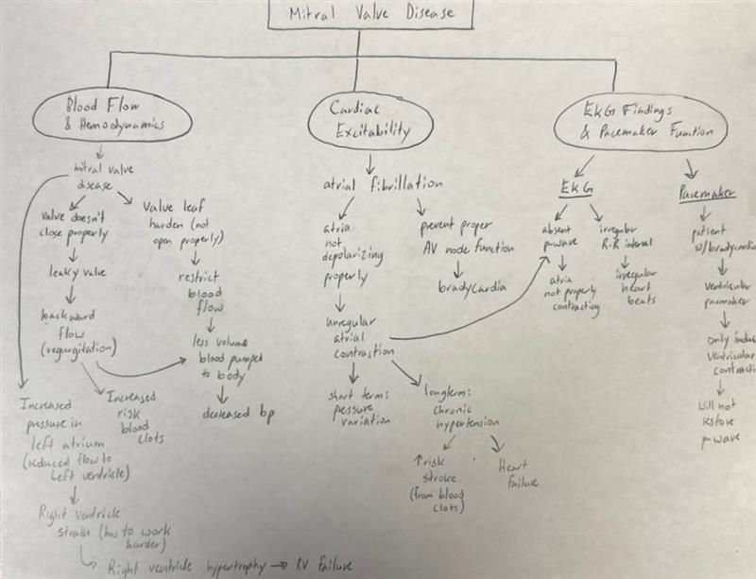
Back to Data Analysis:
11. Now go back and take a look at the class data from the AFib AI/ML model on the class Spreadsheet. Use it to discuss/answer the questions below. Look at two sheets: The Manual Diagnostics Summary sheet shows how well you and your classmates did at evaluating ECGs for AFib. The Neural Network Accuracy Summary sheet shows how the AI tool did at classifying ECG signals. [All completion grade only]
- Based on the accuracy of the class (Manual) diagnosis and the accuracy of the AI tool (Neural Network), how would a positive diagnosis of A-Fib from either your classmate or from the AI tool affect the treatment you would give the patient?
- How does the accuracy of the AI tool compare to different levels of doctor (Manual). How does that affect your evaluation of the accuracy of the AI tool?
- How is B. affected by the inference time it takes the AI tool to interpret one ECG?
- Based on what you have seen today, what role do you think AI/ML has in diagnosing cardiac measures (ECGs, blood pressure, patient symptoms, medical records, etc.) now and in the future?

- What is one thing about this entire PSS that your group is struggling with or confused by?

